

A CAPSTONE PROJECT REPORT

Intelligent Transit Route Optimization with Real-Time Visualization and Time-Aware Routing

A Capstone Project Report submitted in partial fulfilment of the requirements for the Course of

CSA0609 – DESIGN AND ANALYSIS OF ALGORITHMS

to the award of the degree of

BACHELOR OF ENGINEERING

IN
COMPUTER SCIENCE AND ENGINEERING

Submitted by
Jeeva (192421334)

Under the Supervision of
Dr. P. Solainayagi

SIMATS ENGINEERING
Saveetha Institute of Medical and Technical Sciences Chennai-602105

SEPTEMBER 2026

SIMATS ENGINEERING
Saveetha Institute of Medical and Technical Sciences Chennai-602105

BONAFIDE CERTIFICATE

This is to certify that the Capstone Project entitled “Intelligent Transit Route Optimization with Real-Time Visualization and Time-Aware Routing” has been carried out by Jeeva (192421334) the supervision of Dr. P. Solainayagi and is submitted in partial fulfilment of the requirements for the current semester of the B. E Computer Science and Engineering program at Saveetha Institute of Medical and Technical Sciences, Chennai.

COURSE COORDINATOR COURSE FACULTY
Dr. F. Mary Harin Fernandez Dr. P. Solainayagi
Professor Professor
Department of CSE Department of CSE
SIMATS Engineering, SIMATS Engineering,
SIMATS, Chennai – 602105. SIMATS, Chennai – 602105.

SIMATS ENGINEERING
Saveetha Institute of Medical and Technical Sciences Chennai-602105

DECLARATION

I, Jeeva (192421334) of the Computer Science and Engineering, SIMATS Engineering, Saveetha Institute of Medical and Technical Sciences, Chennai, hereby declare that the Capstone Project Work entitled “Intelligent Transit Route Optimization with Real-Time Visualization and Time-Aware Routing” is the result of our own bonafide efforts. To the best of our knowledge, the work presented herein is original, accurate, and has been carried out in accordance with the principles of engineering ethics and academic integrity. All sources, references, data, and other materials used in the project have been appropriately acknowledged. We further declare that the data, results, analysis, and findings presented in this report have not been fabricated, falsified, or manipulated. Any external tools, software, datasets, computational resources, or AI-assisted tools used during the project have been appropriately disclosed. We confirm that all applicable ethical, academic, institutional, and professional requirements have been duly followed throughout the planning, execution, analysis, and documentation of the project.

Place:
Date:

Signature of the Students with Names

SIMATS ENGINEERING
Saveetha Institute of Medical and Technical Sciences Chennai-602105

Individual Contribution Statement

Student Name / Register No. | Specific  Responsibilities | Design & Development Contribution | Testing & Analysis  Contribution | Report Contribution | Approx.  Contribution (%)
S. R. Jeeva  (192421334) | Module 1 and predictive analysis | Dynamic traffic network, Dijkstra routing and traffic prediction model | Dynamic-weight and route validation tests | Module 1, analysis and documentation | 25%
Jeeva  (192421334) | Module 2 and route optimization | A* routing, time-aware routing and multi-vehicle coordination | Alternative-route and route-score analysis | Module 2, testing and results | 25%
R. Ranjitha  (192421285) | Module 3 and signal/emergency management | Greedy signal scheduling and emergency green corridor | Signal timing, priority routing and scenario tests | Module 3 and supporting sections | 25%
B. Naga Nikhitha  (192525086) | Module 4 and visualization | Simulation, analytics, route comparison and dashboard design | What-if scenarios and algorithm comparison | Module 4, conclusion and presentation | 25%
Total |  |  |  |  | 100%

ABSTRACT

Urban transportation networks face increasing congestion, unpredictable travel times, inefficient signal timing, and delays for emergency vehicles. The proposed Intelligent Transit Route Optimization with Real-Time Visualization and Time-Aware Routing system addresses these challenges by combining dynamic graph processing, predictive traffic analysis, multi-vehicle coordination, adaptive traffic signal control, emergency priority routing, and real-time visualization.
The transportation network is represented as a dynamic weighted graph in which intersections are modeled as nodes and roads as weighted edges. Dijkstra’s algorithm is used to determine an initial shortest and least-cost route, while A* search is used for faster time-aware routing and continuous rerouting under changing conditions. Historical and real-time traffic information is used to estimate congestion and dynamically update road weights. A Greedy scheduling strategy adapts traffic signal timings and supports emergency green corridors. Floyd–Warshall and Bellman–Ford are included for route comparison, validation, and alternative-path analysis.
The system further provides multi-objective route selection using travel time, distance, traffic, fuel consumption, carbon emissions, and safety considerations. An interactive visualization and what-if simulation layer enables users to study accidents, road closures, sudden traffic increases, and signal failures. The project therefore demonstrates how classical algorithms can be integrated into a practical intelligent transportation framework to improve routing efficiency, traffic flow, emergency response, and sustainability.

Keywords: Intelligent Transportation System, Dynamic Graph, Dijkstra, A*, Greedy Algorithm, Floyd–Warshall, Bellman–Ford, Traffic Prediction, Route Optimization, Emergency Routing, Real-Time Visualization.

TABLE OF CONTENTS

Sl.  No | Title | Page  No
i | CERTIFICATE FROM THE SUPERVISOR | ii
ii | DECLARATION BY THE CANDIDATE | iii
Iii | INDIVIDUAL CONTRIBUTION STATEMENT | iv
iv | ABSTRACT | v
v | LIST OF FIGURES | vi
vi | LIST OF TABLES | vii
vii | LIST OF ABBREVIATIONS | viii
1 | CHAPTER 1: Introduction
2 | CHAPTER 2: Literature Review
3 | CHAPTER 3: Engineering Design & Trade-offs, Sustainability,  Ethics, Safety, Risk & Security
4 | CHAPTER 4: Implementation, Testing & Results, Project  Management
5 | CHAPTER 5: Conclusion & Reflection
 | References
 | Appendices

LIST OF FIGURES

Figure No. | Figure Name | Page No.
1 | System Implementation | 30
2 | Dashboard | 31

LIST OF TABLES

Table  No. | Table Name | Page  No.
1 | Review of Existing Work | 13
2 | Comparitive Analysis | 13
3 | Stakeholder / User Requirements | 15
4 | Functional and Non Functional Requirements | 15
5 | Constraints & Applicable Standards | 15
6 | Constraints & Applicable Standards | 16
7 | Evaluation | 16
8 | Trade Off Analysis | 17
9 | Sustainability, Ethics, Safety, Risk & Security | 17
10 | Risk Register | 18
11 | Resource | 19
12 | Tools Used | 19
13 | Verification | 19
14 | Results | 20
15 | Comparision | 22
16 | Project Planning | 22

CHAPTER 1

INTRODUCTION AND ENGINEERING PROBLEM

  - Background
Rapid urbanization and increasing vehicle ownership place significant pressure on transportation networks. Traffic congestion increases travel time, fuel consumption, operating cost and carbon emissions. Conventional navigation systems generally provide route guidance for an individual vehicle, but they do not fully coordinate the complete road network, multiple vehicles, traffic signals and emergency movements.
The proposed project treats transportation as a dynamic graph. Intersections are represented as nodes and road segments as weighted edges. The weight of an edge can change according to traffic density, expected travel time, road condition, incidents and other operational factors. This allows route computation to respond to the current state of the network instead of relying on static distances.

  - Need for the Project
- Congestion can change rapidly because of traffic volume, accidents and road closures.
- A route that is shortest by distance may not be fastest under current traffic conditions.
- Routing many vehicles through one shortest path can create secondary congestion.
- Fixed traffic signal timings may increase waiting time at busy intersections.
- Emergency vehicles require coordinated priority instead of ordinary route guidance.
- Transport planners need simulation and visualization tools to evaluate what-if scenarios.
- Travel time, fuel use and emissions should be considered together rather than optimizing only distance.

  - Problem Statement
Design and develop an intelligent transit route optimization system that models a transportation network as a dynamic graph, predicts changing traffic conditions, calculates time-aware routes, coordinates multiple vehicles, adapts signal timings, provides emergency priority routing, and visualizes network behaviour in real time while supporting what-if simulation.

  - Project Aim

To develop an AI-driven intelligent transportation framework that improves route efficiency, traffic flow, emergency response and sustainability through dynamic algorithms and real-time visualization.

  - Project Objectives

- Develop an AI-driven intelligent transportation system for efficient route planning and traffic management.
- Identify shortest and fastest routes using Dijkstra and A* algorithms.
- Predict future traffic congestion using real-time and historical traffic information.
- Optimize routes for multiple vehicles and reduce concentration on a single road.
- Dynamically control traffic signal timings according to traffic density.
- Provide priority routing and green corridors for emergency vehicles.
- Minimize travel time, fuel consumption and carbon emissions through multi-objective route selection.
- Provide real-time visualization and what-if simulation for accidents, road closures and sudden traffic changes.

1.6 Scope
The scope includes dynamic road-network modelling, traffic-data processing, predictive congestion estimation, shortest and fastest route computation, alternative-route generation, multi-vehicle coordination, adaptive signal control, emergency priority routing, route comparison, simulation and visualization. The system is intended as a prototype or decision-support framework rather than a replacement for certified traffic-control infrastructure.
1.7 Expected Engineering Outcome
The expected outcome is a modular intelligent transportation prototype in which classical graph and scheduling algorithms cooperate with traffic information and visualization. The system should demonstrate that route recommendations can change when network conditions change, that vehicle loads can be distributed across alternatives, and that emergency vehicles can receive coordinated priority.

CHAPTER 2

LITERATURE REVIEW AND EXISTING SOLUTIONS

2.1 Review Method

The review considers research on adaptive traffic signal control, reinforcement learning, dynamic routing, multi-intersection coordination and intelligent transportation. The project literature survey supplied in the presentation focuses primarily on learning-based signal optimization and identifies limitations where route optimization, vehicle coordination or complete network integration are not central.

2.2 Review of Existing Work

No. | Research Paper / Authors | Year | Existing Approach | Limitation
1 | Adaptive Optimization of Traffic Signal Timing via Deep Reinforcement Learning – Zibo Ma et al. | 2021 | Deep reinforcement learning for signal timing | Limited route optimization
2 | Traffic Signal Optimization for Multiple Intersections Based on Reinforcement Learning – Jaun Gu et al. | 2021 | Reinforcement learning for multiple intersections | Limited vehicle coordination
3 | Deep Reinforcement Learning for Traffic Signal Control with Consistent State and Reward Design – Bouktif et al. | 2023 | Deep RL with state/reward design | Focus remains mainly on signal control
4 | Adaptive Urban Traffic Signal Control Based on Enhanced Deep Reinforcement Learning – Cai and Wei | 2024 | Enhanced DRL for urban signals | Limited dynamic routing integration
5 | Joint Control of Traffic Signal Phase Sequence and Timing – Sun et al. | 2025 | DRL for signal phase and timing | Limited complete route integration

2.3 Comparative Analysis

Existing Approach | Advantages | Limitations | Relevance
Static shortest-path routing | Simple and predictable | Ignores changing traffic | Baseline routing
Real-time individual navigation | Responds to current traffic | Limited network-level coordination | Current practice
Reinforcement-learning signal control | Adaptive signal decisions | May not solve routing and vehicle distribution together | Useful signal-control reference
Proposed integrated framework | Combines routing, prediction, coordination, signals and visualization | Higher implementation complexity | Selected approach

2.4 Research / Engineering Gap

The literature supplied for the project demonstrates strong progress in adaptive traffic signal control, particularly through reinforcement learning. However, the project identifies a broader engineering requirement: route optimization, traffic prediction, multi-vehicle coordination, signal control, emergency priority and visualization must operate together. A system that optimizes only signals may not prevent route-induced congestion, while a route-only system may ignore intersection delays and emergency movements.

2.5 Proposed Contribution

The project contribution is an integrated algorithmic framework that combines classical graph algorithms with dynamic traffic information. Dijkstra provides an initial least-cost route; A* uses current conditions and a heuristic to improve time-aware search; Greedy scheduling supports adaptive signals and emergency priority; Floyd–Warshall enables all-pairs route comparison; and Bellman–Ford provides an alternative route-validation mechanism when edge costs change.

The design also emphasizes interpretability. Each route can be compared using travel time, distance, traffic, fuel consumption, carbon emissions and safety. This makes the system suitable for experimentation and academic evaluation while leaving room for later machine-learning enhancements.

CHAPTER 3

ENGINEERING DESIGN & TRADE-OFFS, SUSTAINABILITY, ETHICS, SAFETY, RISK & SECURITY

3.1 Requirements

Stakeholder / User Requirements

Stakeholder | Requirement
End User | Receive efficient, understandable and updated route recommendations.
Traffic/System Administrator | Monitor network conditions and adjust configuration or scenarios.
Transport Planner | Evaluate congestion, alternative routes, signals and what-if conditions.
Emergency Operator | Obtain priority routing and coordinated green-corridor support.
Project Evaluator | Verify algorithmic performance, correctness and responsiveness using measurable tests.

Functional & Non-Functional Requirements

Type | Requirement | Measurable Target
Functional | Dynamic graph processing | Road weights update when traffic/incident data changes
Functional | Initial shortest route | Dijkstra returns a valid minimum-cost route
Functional | Time-aware routing | A* returns a valid route using updated conditions
Functional | Traffic prediction | Predicted congestion indicators are produced from available data
Functional | Multi-vehicle coordination | Vehicles can be distributed across suitable alternatives
Functional | Adaptive signals | Signal timings change according to density
Functional | Emergency priority | Priority route and green corridor are generated
Functional | Visualization | Routes, vehicles, signals and conditions are displayed
Non-Functional | Efficiency | Algorithm execution and visualization remain responsive
Non-Functional | Scalability | Design supports increasing nodes, edges and vehicles
Non-Functional | Usability | Outputs are understandable to users and evaluators
Non-Functional | Reliability | Repeated test scenarios produce consistent results

3.2 Constraints & Applicable Standards

The prototype is an academic decision-support system and should not be connected directly to live traffic-control infrastructure without authorization, validation and safety certification. Technical constraints include changing traffic data, incomplete information, graph size, computational cost, prediction uncertainty and the need to avoid unsafe automated control. Data minimization and access control should be applied when real GPS or vehicle information is used.

Constraint / Requirement | How Applied in This Project
Controlled testing | Use simulated or approved traffic scenarios for experiments.
Data minimization | Use only the traffic, route and vehicle attributes needed for analysis.
Algorithm correctness | Validate computed routes against graph costs and known test cases.
Performance | Measure execution time, path cost and nodes explored.
Safety | Treat adaptive signal decisions as simulation outputs unless separately authorized.
Privacy | Avoid storing personally identifying GPS information in the prototype dataset.
Interoperability | Use clearly defined inputs and outputs between modules.

3.3 Design Specifications

Parameter | Target / Requirement | Priority
Network model | Dynamic weighted graph | High
Routing | Dijkstra + A* | High
Prediction | Real-time + historical traffic inputs | High
Vehicle coordination | Alternative-route distribution | High
Signal control | Greedy adaptive scheduling | High
Emergency management | Priority routing + green corridor | High
Simulation | Accidents, closures, traffic spikes, signal failures | Medium
Visualization | Real-time route/network dashboard | High
Analytics | Time, cost, nodes explored, efficiency | High

3.3 Design Specifications

Parameter | Target / Requirement | Priority
Network model | Dynamic weighted graph | High
Routing | Dijkstra + A* | High
Prediction | Real-time + historical traffic inputs | High
Vehicle coordination | Alternative-route distribution | High
Signal control | Greedy adaptive scheduling | High
Emergency management | Priority routing + green corridor | High
Simulation | Accidents, closures, traffic spikes, signal failures | Medium
Visualization | Real-time route/network dashboard | High
Analytics | Time, cost, nodes explored, efficiency | High

3.5 Selected Design & Detailed Design

Component | Responsibility
Traffic Data Manager | Collects and prepares current and historical traffic information.
Dynamic Graph Engine | Represents intersections and roads and updates edge weights.
Dijkstra Router | Computes initial shortest/least-cost routes.
A* Router | Computes time-aware routes and reroutes when conditions change.
Prediction Layer | Estimates congestion and expected travel-time changes.
Vehicle Coordinator | Distributes vehicles across suitable alternative routes.
Greedy Signal Controller | Allocates signal priority according to density and urgency.
Emergency Manager | Detects priority vehicles and coordinates green corridors.
Simulation Engine | Creates accidents, closures, traffic spikes and signal failures.
Visualization Dashboard | Displays network state, routes, traffic and analytics.

3.6 System Architecture

The architecture follows the four modules presented in the project: Dynamic Traffic Network & Predictive Analysis; Intelligent Multi-Vehicle Route Optimization; Adaptive Traffic Signal & Emergency Management; and Smart Simulation, Analytics & Real-Time Visualization.

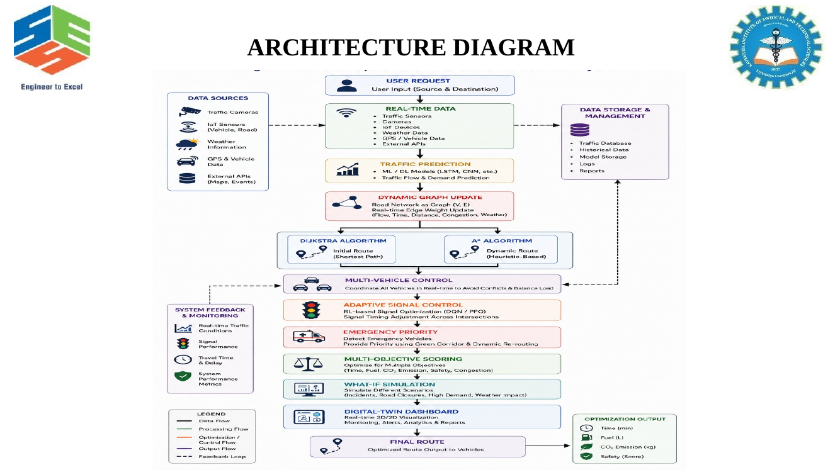

Figure 1. System Architecture

3.7 Algorithmic Flow

The system first accepts source, destination, road-network and traffic information. Dijkstra determines the initial route. Traffic prediction updates expected conditions and edge weights. A* then searches for a time-aware route. If several vehicles are present, the coordinator evaluates alternative routes and distributes vehicles to reduce concentration. Signal control adapts intersection timings, while emergency vehicles receive priority. Finally, the visualization and simulation layer presents the current solution and evaluates alternatives.

3.8 Trade-off Analysis
Design Decision | Alternative Considered | Benefit | Disadvantage | Final Decision & Justification
Dynamic graph weights | Static edge weights | Reflects changing conditions | Requires continuous updates | Selected because traffic is time-varying.
A* for time-aware routing | Only Dijkstra | Faster focused search with heuristic | Heuristic design required | Selected for responsive rerouting.
Multi-algorithm framework | Single algorithm | Uses each algorithm where it fits best | Higher integration complexity | Selected for complete system coverage.
Greedy signal scheduling | Fixed timings | Adapts to density and priority | Locally greedy decisions | Selected for a practical prototype.
Real-time visualization | Text-only output | Improves understanding and monitoring | Additional implementation effort | Selected for analysis and what-if studies.

3.9 Sustainability, Ethics, Safety, Risk & Security
Domain | Consideration | Evidence Evaluated | Impact on Final Decision
Sustainability | Reduce fuel use, waiting and emissions | Route and congestion metrics | Multi-objective routing selected
Ethics | Responsible use of traffic and GPS data | Data minimization and authorization | Simulation-first design
Safety | Avoid unintended signal control | Controlled scenarios and validation | Prototype outputs require human oversight
Privacy | Protect location-related information | No unnecessary personal data | Use aggregated/synthetic data where possible
Security | Protect system configuration and data | Access control and integrity | Restricted administrative actions

Risk Register
Risk | Likelihood | Severity | Risk Level | Mitigation | Residual Risk
Incorrect traffic prediction | Medium | High | High | Use historical + current data and validate scenarios | Medium
Route becomes congested after assignment | Medium | High | High | Continuous monitoring and rerouting | Medium
Algorithm execution cost grows with network size | Medium | Medium | Medium | Use A* for focused search and benchmark complexity | Low
Greedy signal decision is locally suboptimal | Medium | Medium | Medium | Evaluate against scenarios and compare alternatives | Medium
Emergency priority conflicts with ordinary traffic | Low | High | High | Use simulated coordination and safety constraints | Low
Data privacy issue | Low | High | Medium | Minimize and anonymize traffic data | Low
Visualization lag | Medium | Medium | Medium | Separate computation and rendering pipelines | Low

CHAPTER 4

IMPLEMENTATION, TESTING & RESULTS, PROJECT MANAGEMENT

4.1 Development Approach & Resources

The implementation follows an incremental approach. First, the road network and dynamic edge-weight model are defined. Next, Dijkstra and A* are integrated and verified on controlled graphs. Traffic prediction and dynamic updates are then added. Multi-vehicle coordination and Greedy signal scheduling are integrated after the basic routing layer is stable. Finally, simulation, analytics and visualization are connected so that the complete system can be evaluated under normal and incident scenarios.

Resource | Purpose
Development environment | Algorithm implementation and debugging
Graph/network dataset | Represent intersections and roads
Traffic data / synthetic scenarios | Dynamic weight and prediction experiments
Visualization environment | Real-time display and what-if simulation
Spreadsheet / plotting tool | Metric comparison and result analysis
Version-controlled project files | Track incremental development and integration

4.2 Tools / Software / Modern Methods Used

Tool / Method | Purpose | Stage Used
Python or equivalent programming environment | Algorithm and prototype implementation | Development
Graph data structures | Nodes, edges and dynamic weights | Implementation
Dijkstra Algorithm | Initial shortest route | Module 1
A* Search | Time-aware route optimization | Module 2
Greedy Scheduling | Adaptive signals and priority | Module 3
Floyd–Warshall | All-pairs comparison | Module 4
Bellman–Ford | Route validation and alternatives | Module 4
Dashboard / plotting framework | Visualization and analytics | Testing / Analysis

4.3 Module 1 – Dynamic Traffic Network & Predictive Analysis

Dijkstra identifies the initial shortest and least-cost route.
The road network is represented as a weighted graph.
Real-time traffic, GPS, vehicle density and road-condition information are treated as inputs.
Historical and current patterns are used to estimate possible congestion.
Road weights are updated according to traffic density, accidents, road conditions and expected travel time.
Output includes the dynamic network, predicted traffic condition, initial route and estimated travel time.

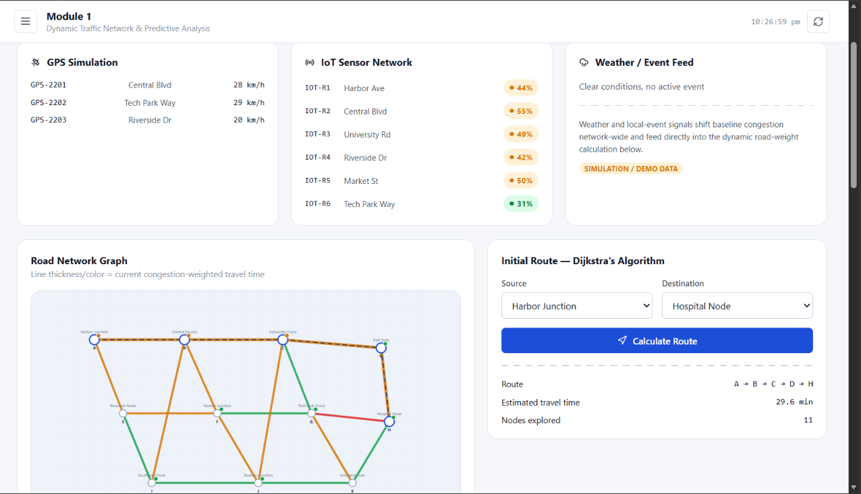
Figure 2. Module 1 Output

4.4 Module 2 – Intelligent Multi-Vehicle Route Optimization
A* Search identifies the fastest and efficient route using updated road conditions.
Traffic congestion, accidents, road closures and unexpected changes are continuously considered.
Alternative routes are generated when the current route becomes inefficient.
Multiple vehicles are distributed across suitable routes to prevent excessive concentration.
Route selection considers travel time, distance, traffic, fuel consumption, carbon emissions and safety.
Output includes best route, alternatives, vehicle distribution, route score and updated ETA.
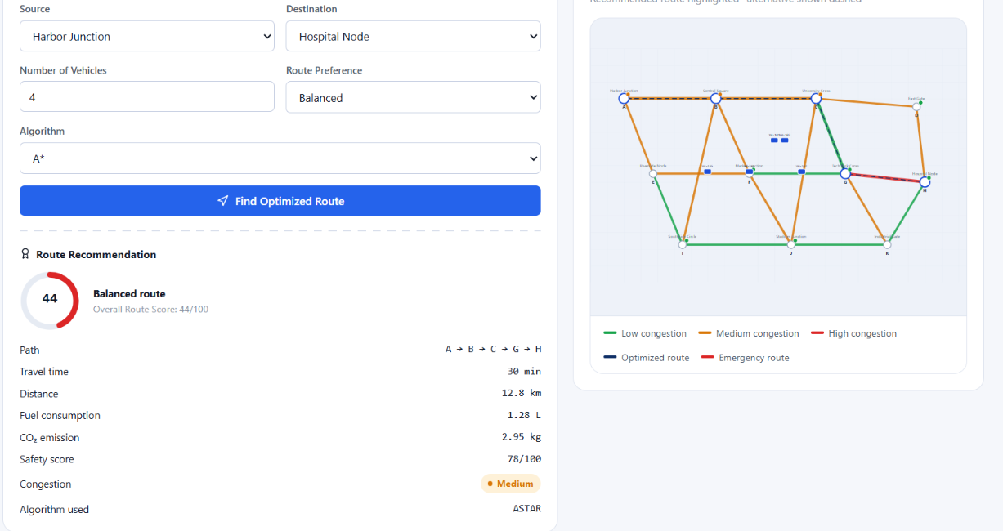
Figure 3. Module 2 Output

4.5 Module 3 – Adaptive Traffic Signal & Emergency Management
Greedy scheduling adjusts signal timings according to current traffic density.
Heavily congested directions receive suitable green-light duration.
Emergency vehicles are given priority routing.
Traffic signals along the selected emergency route are coordinated to form a green corridor.
Outputs include adaptive signal timing, emergency priority route, green corridor, reduced waiting time and improved traffic flow.

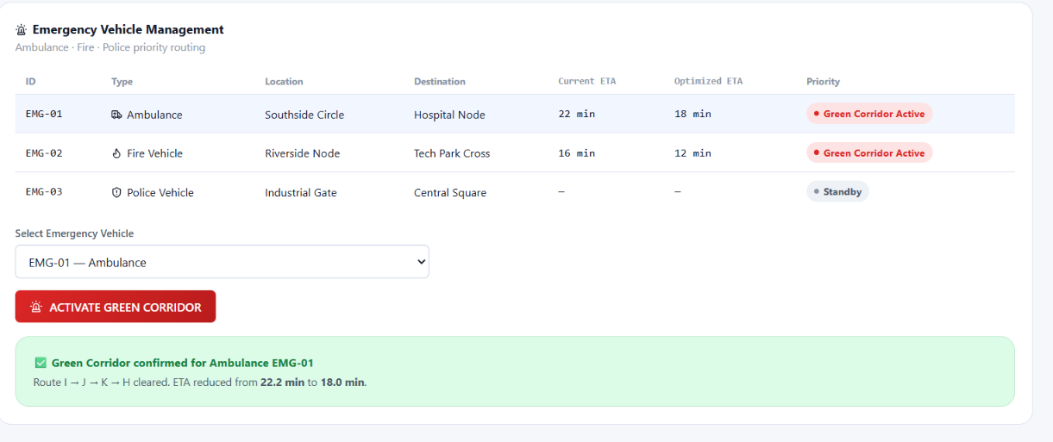
Figure 4. Module 3 Output

4.6 Module 4 – Smart Simulation, Analytics & Real-Time Visualization
Floyd–Warshall and Bellman–Ford support route comparison, validation and alternative-path analysis.
The dashboard visualizes routes, traffic density, vehicles, road conditions and signals.
Routes are compared using travel time, distance, fuel consumption, carbon emissions, traffic and safety.
What-if simulation covers accidents, road closures, sudden traffic increases and signal failures.
Algorithm performance is evaluated using execution time, path cost, nodes explored and computational efficiency.

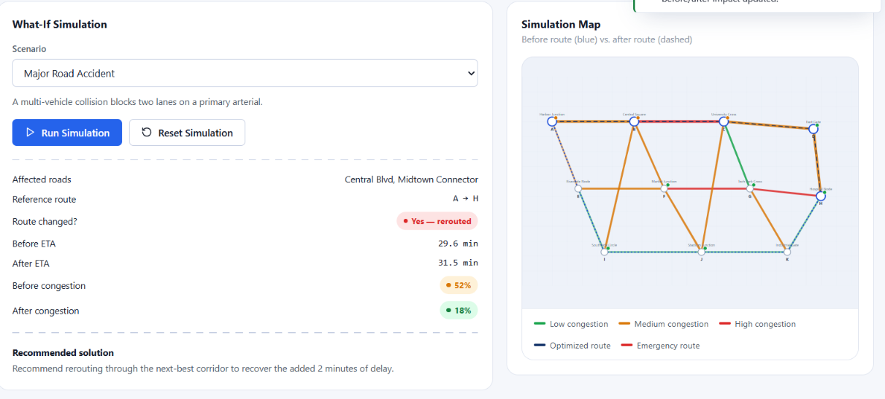
Figure 5. Module 4 Output

4.7 Test Plan & Verification

Requirement | Test Method | Acceptance Criterion
Dijkstra route | Run on known weighted graph | Returned path has minimum cost
A* route | Run with admissible heuristic | Valid route with expected/competitive cost
Dynamic weight update | Change traffic on selected road | Route calculation responds to changed weight
Multi-vehicle coordination | Assign multiple vehicles to same origin/destination | Vehicles can be distributed across alternatives
Signal adaptation | Increase density on one approach | Signal allocation changes toward congested direction
Emergency priority | Introduce emergency vehicle | Priority route and corridor are generated
Accident simulation | Close a road edge | Affected route is avoided or recalculated
Traffic spike | Increase edge congestion values | Updated ETA/route reflects changed conditions
Visualization | Run complete scenario | Network and route state are displayed
Algorithm comparison | Run multiple algorithms on same graph | Metrics are recorded consistently

4.8 Results / Expected Evaluation

Metric | Required / Target | Achieved / Evidence | Status
Route correctness | Valid minimum/efficient route | Verified using controlled graph scenarios | To be evaluated quantitatively
Rerouting responsiveness | Route changes after significant weight update | Dynamic update test scenario | To be measured
Vehicle distribution | Reduced concentration on one route | Multi-vehicle simulation | To be measured
Signal adaptation | Timing changes with density | Intersection scenario | To be measured
Emergency response | Priority route and green corridor | Emergency scenario | Demonstrated conceptually
Visualization | Current network state visible | Dashboard output | Demonstrated in PPT
Algorithm efficiency | Execution time and nodes explored recorded | Comparison framework | To be measured

4.9 Data Analysis & Engineering Judgment

The most important engineering judgement is that shortest distance alone is insufficient for intelligent transit routing. Edge weights must represent operational cost, including travel time and traffic. A route that is geographically short can become inferior when congestion rises. Therefore, dynamic weight updates and time-aware A* routing are central to the design.
Multi-vehicle routing introduces a second level of complexity. Even if a route is optimal for one vehicle, assigning many vehicles to it may increase its traffic cost. The coordinator therefore evaluates alternative routes and distributes vehicles. Signal scheduling is similarly treated as a dynamic decision rather than a fixed timetable.
The project should report execution time, path cost, nodes explored, rerouting frequency, waiting time, vehicle distribution, and scenario outcomes. Because the supplied presentation describes the architecture and intended outputs but does not provide measured benchmark values, numerical performance claims are intentionally left as evaluation targets rather than invented results.

4.10 Comparison with Existing Solutions & Achievement of Objectives
Objective | Evidence | Achievement
Develop intelligent route optimization | Integrated dynamic graph and routing modules | Implemented as proposed architecture
Identify shortest and fastest routes | Dijkstra and A* modules | Supported
Predict congestion | Historical and current traffic inputs | Framework defined
Coordinate multiple vehicles | Vehicle distribution logic | Supported in Module 2
Adaptive traffic signals | Greedy scheduling module | Supported in Module 3
Emergency green corridor | Priority route + coordinated signals | Supported in Module 3
Multi-objective optimization | Time, distance, fuel, emissions, safety | Supported
Visualization and what-if simulation | Module 4 dashboard and scenarios | Supported in project design

4.11 Strengths & Limitations
Strengths:
- Integrates multiple classical algorithms according to their strengths.
- Adapts route costs to changing traffic and road conditions.
- Supports multi-vehicle coordination rather than only individual routing.
- Includes adaptive signal control and emergency priority.
- Provides real-time visualization and what-if simulation.
- Supports multi-objective evaluation beyond distance alone.
Limitations:
- Prediction quality depends on the quality and availability of traffic data.
- The Greedy strategy may produce locally optimal rather than globally optimal signal decisions.
- Large graphs can increase computational cost for all-pairs algorithms such as Floyd–Warshall.
- Real-world signal control requires safety validation and regulatory authorization.
- The supplied project material does not contain numerical benchmark measurements for final performance claims.
- GPS and vehicle data can raise privacy and security concerns if real personal data is used.

4.12 Project Planning, Roles & Budget

Milestone | Weeks | Deliverable
Problem definition and literature review | 1–2 | Requirements and literature survey
Architecture and graph model | 3–4 | System architecture and dynamic graph design
Module 1 development | 5–6 | Traffic network and prediction model
Module 2 development | 7–8 | A* and multi-vehicle optimization
Module 3 development | 9–10 | Signal and emergency management
Module 4 integration | 11–12 | Simulation, analytics and visualization
Testing and documentation | 13–14 | Evaluation, report and presentation

Student | Assigned Responsibility | Approx. Contribution
S. R. Jeeva | Module 1, traffic network and predictive analysis | 25%
Jeeva | Module 2, A* routing and vehicle coordination | 25%
R. Ranjitha | Module 3, adaptive signals and emergency management | 25%
B. Naga Nikhitha | Module 4, visualization, simulation and documentation | 25%

Item | Estimated Cost | Actual Cost
Development software | ₹0–₹5,000 | To be entered
Data / simulation resources | ₹0–₹3,000 | To be entered
Documentation / miscellaneous | ₹0–₹1,000 | To be entered
Total | ₹0–₹9,000 | To be entered

CHAPTER 5
CONCLUSION, FUTURE WORK AND REFLECTION

5.1 Conclusion
The Intelligent Transit Route Optimization with Real-Time Visualization and Time-Aware Routing project presents an integrated algorithmic approach to intelligent transportation. The proposed architecture represents the road network as a dynamic graph and combines Dijkstra, A*, Greedy, Floyd–Warshall and Bellman–Ford algorithms for complementary routing, scheduling, validation and comparison tasks.
The system addresses limitations of conventional individual route guidance by considering dynamic traffic conditions, multi-vehicle coordination, adaptive traffic signals and emergency priority. Its multi-objective route model incorporates travel time, distance, traffic, fuel consumption, carbon emissions and safety. The real-time visualization and what-if simulation layer further supports analysis of accidents, road closures, traffic spikes and alternative network states.
The project therefore demonstrates a practical foundation for faster, safer, more adaptive and sustainable transportation planning. Quantitative benchmark values should be added after running the defined test cases on the final implementation.

5.2 Future Work

- Integrate machine-learning models for more accurate congestion prediction.
- Use reinforcement learning for globally optimized traffic signal control.
- Incorporate live traffic feeds and validated map data.
- Add stronger multi-agent vehicle coordination.
- Develop automated incident detection from sensor and camera feeds.
- Add privacy-preserving processing for GPS and vehicle information.
- Extend the dashboard with historical trend analysis and route recommendations.
- Benchmark algorithms on large-scale real-world road networks.
- Add formal safety constraints before any connection to real traffic-control systems.

5.3 Professional Learning & Individual Reflection

New Knowledge Acquired:
Dynamic graph modelling for transportation networks.
Shortest-path and heuristic search algorithms in practical routing.
Trade-offs between individual and network-level optimization.
Adaptive scheduling for traffic signals.
Scenario-based simulation and algorithm performance analysis.
Engineering & Professional Skills Developed:
System architecture and modular algorithm design.
Experimental planning and measurable verification.
Technical documentation and communication.
Risk assessment, sustainability and ethical reasoning.
Team-based development and integration.
Individual Reflection – S. R. Jeeva (192421334): The main learning was how dynamic traffic information can change the cost structure of a graph and therefore change the selected route. Working on the predictive traffic network module highlighted the importance of separating raw traffic inputs from routing decisions.
Individual Reflection – Jeeva (192421334): The major challenge was designing route selection that is sensitive to travel time and changing conditions rather than distance alone. The A* module and multi-vehicle coordination showed that an efficient route for one vehicle may not remain efficient when many vehicles use the same road.
Individual Reflection – R. Ranjitha (192421285): The signal and emergency module demonstrated that route optimization must also consider intersection-level delay. Designing adaptive signal timing and an emergency green corridor emphasized the need to balance ordinary traffic efficiency with emergency priority and safety.
Individual Reflection – B. Naga Nikhitha (192525086): The visualization and simulation module showed how algorithmic outputs become more useful when users can inspect routes, traffic density and what-if scenarios. The work also emphasized that visual demonstrations should be supported by measurable test results.

REFERENCES

[1] Z. Ma, T. Cui, W. Deng, F. Jiang, and L. Zhang, “Adaptive optimization of traffic signal timing via deep reinforcement learning,” Journal of Advanced Transportation, vol. 2021, Article ID 6616702, 2021, doi: 10.1155/2021/6616702.
[2] J. Gu, M. Lee, C. Jun, Y. Han, Y. Kim, and J. Kim, “Traffic signal optimization for multiple intersections based on reinforcement learning,” Applied Sciences, vol. 11, no. 22, Art. no. 10688, 2021, doi: 10.3390/app112210688.
[3] S. Bouktif, A. Cheniki, A. Ouni, and H. El-Sayed, “Deep reinforcement learning for traffic signal control with consistent state and reward design approach,” Knowledge-Based Systems, vol. 267, Art. no. 110440, 2023, doi: 10.1016/j.knosys.2023.110440.
[4] C. Cai and M. Wei, “Adaptive urban traffic signal control based on enhanced deep reinforcement learning,” Scientific Reports, vol. 14, Art. no. 14116, 2024, doi: 10.1038/s41598-024-64885-w.
[5] Z. Sun, X. Jia, Y. Cai, A. Ji, X. Lin, L. Liu, W. Wang, and Y. Tu, “Joint control of traffic signal phase sequence and timing: A deep reinforcement learning method,” Digital Transportation and Safety, vol. 4, no. 2, pp. 118–126, 2025, doi: 10.48130/dts-0025-0008.
The project literature and references are based on the sources listed in the supplied presentation. Additional software, datasets or standards used in the final implementation should be added to the reference list before submission.

APPENDICES

APPENDIX A – SYSTEM MODULE DESCRIPTION

A.1 Module 1 – Dynamic Traffic Network & Predictive Analysis
This module models intersections as nodes and roads as weighted edges. Dijkstra produces the initial shortest/least-cost route. Current traffic, GPS, vehicle density, road condition and historical traffic data are processed to estimate congestion and update road weights.
A.2 Module 2 – Intelligent Multi-Vehicle Route Optimization
This module uses A* search for time-aware route selection. It monitors changing conditions and recalculates routes when the current route becomes inefficient. Multiple vehicles are distributed across alternative routes using route scores based on time, distance, traffic, fuel, emissions and safety.
A.3 Module 3 – Adaptive Traffic Signal & Emergency Management
The module uses Greedy scheduling to allocate signal time according to traffic density. Emergency vehicles receive priority routing and coordinated signal support, forming an emergency green corridor.
A.4 Module 4 – Smart Simulation, Analytics & Real-Time Visualization
Floyd–Warshall and Bellman–Ford are used for route comparison and validation. The dashboard visualizes network conditions and supports what-if simulations for accidents, closures, traffic increases and signal failures.

APPENDIX B – SYSTEM INPUTS AND OUTPUTS

Module | Inputs | Outputs
Module 1 | Source, destination, road network, GPS data, traffic data, historical traffic data | Dynamic road network, predicted traffic condition, initial route, estimated travel time
Module 2 | Updated network, vehicle set, current conditions | Best route, alternative routes, vehicle distribution, route score, updated ETA
Module 3 | Intersection density, vehicle priority, selected routes | Adaptive signal timing, emergency priority route, green corridor, reduced waiting time
Module 4 | Network state, routes, incidents, algorithm results | Visualization, route analytics, simulation results, algorithm comparison, recommendation

APPENDIX C – TECHNIQUES
Artificial Intelligence & Predictive Analytics: estimates congestion and travel conditions.
Dynamic Graph Processing: changes road weights based on current network conditions.
Multi-Vehicle Coordination: distributes vehicles across alternative routes.
Adaptive Traffic Signal Control: adjusts signal timing and emergency priority.
Real-Time Visualization & Simulation: displays routes, traffic, vehicles and scenario outcomes.

PPENDIX D – ALGORITHM
D.1 Dijkstra Algorithm
1. Initialize distance of the source as zero and all other nodes as infinity. 2. Select the unvisited node with minimum distance. 3. Relax all adjacent edges using the current dynamic weights. 4. Mark the node visited. 5. Repeat until the destination is finalized. 6. Reconstruct the shortest path using predecessor information.
D.2 A* Search Algorithm
1. Initialize the open set with the source. 2. Compute g(n), the known cost, and h(n), the heuristic estimate. 3. Select the node with minimum f(n)=g(n)+h(n). 4. Relax neighbouring nodes and update their scores. 5. Continue until the destination is reached. 6. Reconstruct the route. 7. Re-run when traffic conditions materially change.
D.3 Greedy Signal Scheduling
1. Observe density at each approach. 2. Rank approaches by current urgency/density. 3. Allocate green time to the highest-priority approach subject to safety constraints. 4. Update the intersection state. 5. Repeat as traffic changes. Emergency vehicles receive an explicit priority condition.
D.4 Floyd–Warshall
Initialize the distance matrix with direct edge costs. For each intermediate vertex k, update every pair (i,j) using min(distance[i][j], distance[i][k]+distance[k][j]). The final matrix gives shortest-path costs between all pairs.
D.5 Bellman–Ford
Initialize the source distance to zero. Relax all edges repeatedly for |V|-1 iterations. A final relaxation check identifies negative cycles where applicable. In this project it is used primarily for route validation and alternative-path analysis when edge costs change.

APPENDIX E – PSEUDOCODE FOR INTEGRATED ROUTING
START
1. Read source, destination, road network and traffic data.
2. Build dynamic weighted graph.
3. Update road weights from traffic and road conditions.
4. Compute initial route using Dijkstra.
5. Predict near-future congestion from available historical/current data.
6. Recalculate updated weights.
7. Compute time-aware route using A*.
8. If multiple vehicles exist, score alternatives and distribute vehicles.
9. If an emergency vehicle is detected, assign priority route and coordinate signals.
10. Use Floyd–Warshall/Bellman–Ford for comparison and validation where required.
11. Display route, traffic, vehicles, signals and analytics.
12. If a what-if event occurs, modify the graph and repeat from Step 3.
13. Continue until the simulation ends.
END

APPENDIX F – SOFTWARE IMPLEMENTATION STRUCTURE

Component | Representative Data / Function
Graph | nodes, edges, weights, adjacency list/matrix
Traffic record | density, speed, incident, expected travel time
Vehicle | ID, origin, destination, priority, assigned route
Route score | time, distance, traffic, fuel, emissions, safety
Signal state | approach density, green duration, priority status
Scenario | event type, affected road/intersection, time
Analytics | execution time, path cost, nodes explored, waiting time
A modular implementation should keep route calculation, prediction, signal scheduling, simulation and visualization as separate services or functions. This separation makes individual algorithms easier to test and replace.

APPENDIX G – TEST CASES AND EXPECTED RESULTS
Test Case | Input / Activity | Expected Result
TC01 | Normal route request | Valid shortest/efficient route returned
TC02 | Increase traffic on selected road | Dynamic weight increases
TC03 | Close a road | Route avoids closed edge or reports no feasible route
TC04 | Sudden traffic spike | ETA and route recommendation update
TC05 | Multiple vehicles | Vehicles distributed across suitable routes
TC06 | High-density intersection | Adaptive signal allocation changes
TC07 | Emergency vehicle detected | Priority route and green corridor generated
TC08 | Signal failure scenario | Alternative signal/route strategy displayed
TC09 | Algorithm comparison | Execution/path metrics recorded
TC10 | Dashboard scenario | Real-time network state and recommendation displayed

APPENDIX H – SYSTEM OUTPUT / SCREENSHOTS


APPENDIX I – APPLICATIONS
Urban route planning and congestion management.
Public transit route optimization.
Fleet and logistics route coordination.
Emergency response and ambulance routing.
Traffic-signal decision support.
Transport planning and infrastructure studies.
Incident and road-closure simulation.
Sustainability analysis using fuel and emissions metrics.

APPENDIX J – FUTURE ENHANCEMENTS
Machine-learning congestion prediction.
Deep reinforcement learning for signal control.
Cloud-based traffic and map integration.
Automated backup and recovery of simulation state.
Enterprise-scale fleet coordination.
Advanced real-time reporting and alerts.
Faster parallel processing for large graphs.
Privacy-preserving analytics for real vehicle data.
Overall, the appendices provide the technical supporting material for the project, including module descriptions, algorithmic procedures, implementation structure, test cases, output evidence, applications and future enhancements.

CAPSTONE PROJECT OUTCOME MAPPING SHEET

To be completed by the department/faculty assessor.

Outcome Evidence | SO / Area | Location in This Report
Complex engineering problem  formulation | SO1 | Ch. 1, Ch. 2
Engineering design under constraints | SO2 | Ch. 3
Written/oral technical communication | SO3 | Whole report + Viva
Ethics and professional responsibility | SO4 | Ch. 3 (3.7)
Teamwork and leadership | SO5 | Ch. 4 (4.8)
Experimentation, analysis, engineering  judgment | SO6 | Ch. 4 (4.3–4.6)
Independent acquisition of new  knowledge | SO7 | Ch. 5 (5.3)
Standards | SO2 | Ch. 3 (3.2)
Sustainability and  societal/environmental impact | SO2/SO4 | Ch. 3 (3.7)
Risk assessment and mitigation | SO2/SO4 | Ch. 3 (3.7)
Security considerations | Relevant SO | Ch. 3 (3.7)
Integrated/system-level engineering | SO1/SO2 | Ch. 3 (3.5)
Project planning and management | SO5 | Ch. 4 (4.8)
Individual contribution | SO1–SO7 | Contribution Statement + Ch. 4  (4.8)

